OccupyForAccountability.org
POB 9576
Washington, DC 20016
legal@velvetrevolution.us
June 25, 2012

James W. McJunkin
Assistant Director in Charge
FBI Washington Field Office
601 4th Street NW
Washington, DC 20535

Detective Sergeant Morani Hines
Chief, Youth Investigations Branch
Metropolitan Police Department
1700 Rhode Island Avenue, NE
Washington, DC 20018

Re: American Center For Law and Justice/James M. Henderson Sex Abuse/Other Crimes Report With Supporting Evidence

Dear ADIC McJunkin and Detective Sergeant Hines:

OccupyForAccountability is a campaign of the Velvet Revolution advocacy organization that focuses on corporate and government accountability. We have worked closely for several years with Special Agents of the FBI Washington Field Office and with Detectives on the Metropolitan Police Force. Several weeks ago, we received information alleging that a man who works in Washington, DC has been sexually grooming and preying on teenage boys for the past several years through use of the Internet. Even though we do not have first hand knowledge of these alleged crimes, we are obligated by law to report this information to law enforcement officials, and, during the week of June 10, 2012, we did so in abbreviated form to your offices. As requested, we are now providing you a more complete report of the facts, evidence, photos, chats, and timeline as we have received them. We believe that this evidence provides a sufficient basis on which to open a criminal investigation into this matter.

Summary

The American Center for Law and Justice (ACLJ) is a law firm located at 205 Third Street, SE Washington, DC 20003. James M. Henderson, Sr. is Senior Counsel of the ACLJ in the Washington, D.C. office and has been counsel of record on many cases, including amicus briefs to the Supreme Court regarding “The Child Pornography Prevention Act” and “The Child Online Protection Act.” ACLJ states in its Mission Statement that it is a God driven law firm: ACLJ “is dependent upon God and the resources He provides through the time, talent, and gifts of people who share our concerns and desire to protect our religious and constitutional freedoms.”

On or about June 5, 2012, ACLJ announced that it would be representing several clients who have engaged in civil and possible criminal torts against our organization and staff. On June 8, 2012, we received a tip from a whistleblower, who will remain anonymous, stating that he had information relating to criminal activity by American Center For Law And Justice Senior Counsel James. M. Henderson. In short, according to this whistleblower, Mr. Henderson, for at least two years, has been using the pseudonym Kyle Johnson, to groom and prey on teenage boys for sex via the Internet. Mr. Henderson contacts the boys using various means including Facebook and exchanges sexually explicit messages with them. He then meets with them, picks them up in his car, plies them with illegal drugs and alcohol, and takes them to various locations for sex.

Several of these boys determined that Mr. Henderson was a predator and so they began copying his electronic messages, taking pictures of him and his vehicle, taking cell phone videos inside and outside his car, and photographing evidence in his car, including a bank statement with James M. Henderson’s name and address on it. That information was provided to us. We are now providing it to you on a DVD.

The Evidence As Provided By The Whistleblower

The evidence below and in the attached DVD is what we received in good faith. We are not an investigative agency and cannot verify every detail. We understand the serious nature of these charges and want to make sure that this evidence is corroborated and substantiated by other evidence to which your agencies have access. Here is the evidence as provided by the whistleblower.

Sometime in 2010, James Henderson created a Facebook page using the name, Kyle Johnson to groom and prey on teenage boys. See Exhibit A-July 2010 Facebook screenshot. As of today’s date, the page is still online and the last post is dated May 25, 2012. See Exhibit B, current Facebook. http://www.facebook.com/profile.php?id=100000442422057&sk=wall
Mr. Henderson’s Kyle Johnson Facebook page has many comments and references to marijuana and sex. These include references to his personal use of marijuana and, in response to this comment from a boy—“I want to fuck you like an animal” – Mr. Henderson posted a music video about having sex like they “do on the Discovery Channel.”

In a cell phone video taken by one of the boys, Mr. Henderson admitted that Kyle Johnson is not “a real name,” and that he chose that name after seeing a locksmith’s car with the name Kyle Johnson on it. He laughed and said, “that poor guy’s probably in a lot of trouble at home.” The real Kyle Johnson, Locksmith, is located in the Chicago, Il area.
KYLE B JOHNSON |  | 4455 147th St |  | Midlothian, IL | 60445

On at least one occasion, Mr. Henderson met the boys wearing a backwards baseball cap and wrap around sunglasses. See photos at Exhibit C. He drove a teal colored Hyundai, Sante Fe SUV with Virginia license tags XUH 6520. See photo at Exhibit D. He played loud hip-hop and urban music in the car while driving with the boys. On one of the cell phone videos, one of the boys asks Mr. Henderson to buy him some rum. In another video, Mr. Henderson went into an alcohol retailer and requested “Skyy 90” Vodka for the boys. He returned to the boys in the car and stated that they did not carry Skyy 90 but he got them something else.

While Mr. Henderson was out of the car buying the alcohol, one of the boys found a bank statement in the car from BB&T Bank addressed to James M. Henderson and Theresa A. Henderson, 7108 Reservoir Road, Springfield, VA 22150
See photo at Exhibit E. The boy said, “oh my God, that’s him, that’s him.”

Mr. Henderson, as Kyle Johnson, used different chat programs to communicate with the boys, including Facebook Mobile. In one particular chat, Mr. Henderson, using the name Kyle Johnson, said that he was a lawyer, that he had been to North Carolina the week of July 21, 2010 to work on a case, and that he “missed” one of the boys and wanted a “do over.” The boy admitted that he and the other boy had been drinking. Exhibit F.

In another chat, Mr. Henderson as Kyle Johnson and one of the boys admitted that the boys drank a “twelve pack” and “vodka.” Exhibit G. Mr. Henderson as Kyle Johnson admitted that he smoked “a half gram of pot.” He told the boy that he had some more marijuana and could give him if they could meet up on Friday.

One of the boys mentioned in the chat as being with Mr. Henderson has a YouTube channel at http://www.youtube.com/user/JuJuPaP3R which has 91 videos created by the boy.

Conclusion

In conclusion, the evidence presented here and in the accompanying DVD provides a sufficient basis on which to launch robust federal and state investigations of James Henderson for violating a broad range of criminal statutes meant to hold sexual predators accountable for their reprehensible behavior.

We urge this investigation to include any cover-up by staff at the American Center for Law and Justice, and whether Mr. Henderson used computers or other resources of ACLJ to prey on teenage boys. Like the case of Jerry Sandusky, which also occurred over many years, we ask that you investigate who knew what and when, including other staff at ACLJ. We ask you to investigate whether Mr. Henderson acted alone or with the help of others. Also, because ACLJ is involved in sensitive cases involving the Government and foreign affairs, we ask that you investigate whether Mr. Henderson’s conduct breached or compromised confidential matters or matters of national security.

Please let us know if you have any questions.

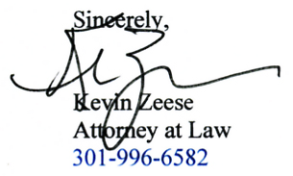
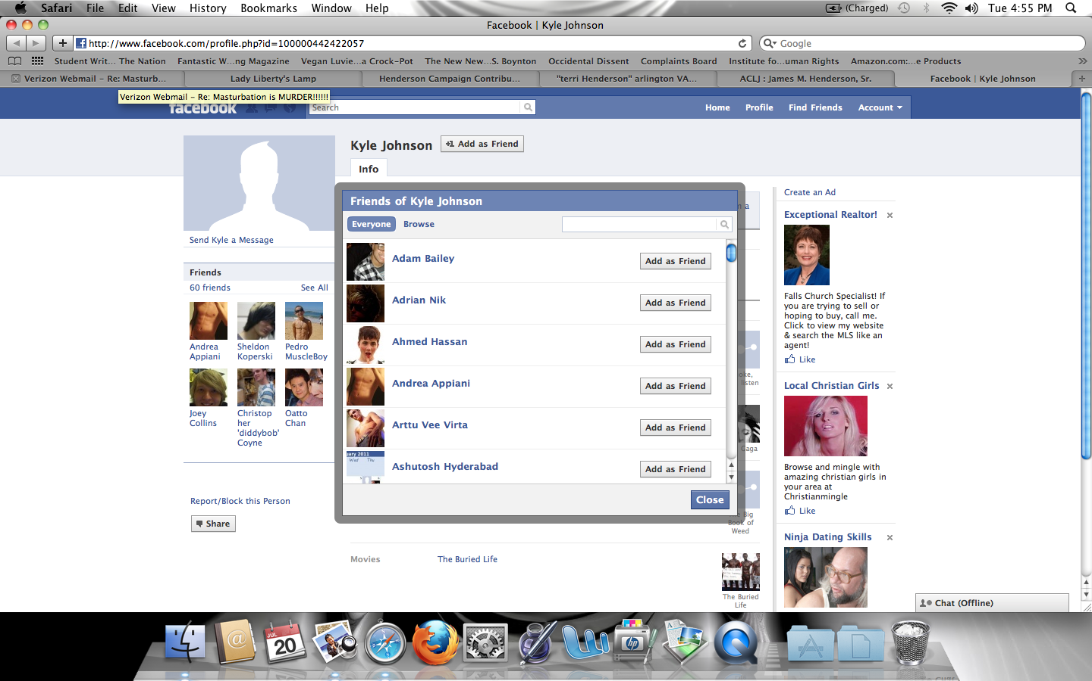

EXHIBIT A

Wall

Info

Photos

- Report/Block...
http://www.facebook.com/profile.php?id=100000442422057&sk=wall

Kyle Johnson
Create an Ad

Sponsored

http://www.facebook.com/profile.php?id=100000442422057&sk=wall

AT&T

Wall
http://www.facebook.com/profile.php?id=100000442422057&sk=wall

Kyle Johnson

Shawn Eoghan Sam Vicki: Hope you are all great!

Share · May 25 at 10:25am · http://www.facebook.com/profile.php?id=100000442422057&sk=wall

  - http://www.facebook.com/profile.php?id=100000442422057&sk=wall
Eoghan Quigg likes this.

    - http://www.facebook.com/profile.php?id=100000442422057&sk=wall
Eoghan Quigg hehe
May 26 at 5:47am

http://www.facebook.com/profile.php?id=100000442422057&sk=wall

Kyle Johnson

Shredded wheat with a sliced banana!! Who says the post-weed munchies have to be entirely unhealthy?

Share · May 15 at 4:29am · http://www.facebook.com/profile.php?id=100000442422057&sk=wall

  - http://www.facebook.com/profile.php?id=100000442422057&sk=wall
Eoghan Quigg likes this.

http://www.facebook.com/profile.php?id=100000442422057&sk=wall

Kyle Johnson

People that I've never met, but still find myself missing when we don't talk. Love you guys!

Share · May 13 at 9:14pm · http://www.facebook.com/profile.php?id=100000442422057&sk=wall

  - http://www.facebook.com/profile.php?id=100000442422057&sk=wall
Eoghan Quigg likes this.

http://www.facebook.com/profile.php?id=100000442422057&sk=wall

Kyle Johnson

It's 420! Do you know where your smoke is?

Share · April 20 at 7:03am · http://www.facebook.com/profile.php?id=100000442422057&sk=wall

    - http://www.facebook.com/profile.php?id=100000442422057&sk=wall
Sam Bennett i wanna fuck you like an animal!
May 11 at 3:03am · 1
    - http://www.facebook.com/profile.php?id=100000442422057&sk=wall
Kyle Johnson http://www.youtube.com/watch?v=xat1GVnl8-k
Bloodhound Gang - The Bad Touch
www.youtube.com
Music video by Bloodhound Gang performing The Bad Touch. (C) 1999 Interscope Records
May 11 at 7:20pm

http://www.facebook.com/profile.php?id=100000442422057&sk=wall

Kyle Johnson

Yes, this is for you. Because I know you love her so:
http://www.youtube.com/watch?v=ScLVtsi0cfc

Ellie Goulding - Your Song (Blackmill Dubstep Remix) + High Quality Download Link
www.youtube.com
Blackmill Debut Album OUT NOW! Download Link Below! http://itunes.apple.com/us/album/reach-for-glory/id423339211?uo=4 When I first heard the original I feel ...

Share · March 27 at 9:40am · http://www.facebook.com/profile.php?id=100000442422057&sk=wall

http://www.facebook.com/profile.php?id=100000442422057&sk=wall

Kyle Johnson

I am the one falling to pieces, just to be clear about things.
Thanks for the ride.

Share · March 27 at 9:18am · http://www.facebook.com/profile.php?id=100000442422057&sk=wall

    - http://www.facebook.com/profile.php?id=100000442422057&sk=wall
Eoghan Quigg wise up old man :L
March 28 at 7:34am · 1
    - http://www.facebook.com/profile.php?id=100000442422057&sk=wall
Kyle Johnson if i'm a fool at my age, can wisdom ever come?
March 28 at 7:42am

http://www.facebook.com/profile.php?id=100000442422057&sk=wall

Kyle Johnson

Things I'm thankful for: the promise of silence, permanent, lasting, uninterrupted. An end of hurts. Tear ducts that don't remember the daily flow. Friends who know when its time to stop pushing and just keep caring. That one spot, when life knocks the fuck out of you, where there's something a little soft to fall on.

Share · March 27 at 9:13am · http://www.facebook.com/profile.php?id=100000442422057&sk=wall

  - http://www.facebook.com/profile.php?id=100000442422057&sk=wall
Eoghan Quigg likes this.

http://www.facebook.com/profile.php?id=100000442422057&sk=wall

Kyle Johnson shared a link.

http://cdn.smosh.com/sites/default/files/bloguploads/worst-schoolads-5.jpg
cdn.smosh.com

Share · February 22 at 2:43pm · http://www.facebook.com/profile.php?id=100000442422057&sk=wall

http://www.facebook.com/profile.php?id=100000442422057&sk=wall

Kyle Johnson

If you see this message, get on msn. i am on a new phone and need my sign in name for touch

Share · February 4 at 10:19pm · http://www.facebook.com/profile.php?id=100000442422057&sk=wall

  - http://www.facebook.com/profile.php?id=100000442422057&sk=wall
3 people like this.

    - http://www.facebook.com/profile.php?id=100000442422057&sk=wall
Sam Bennett told me to drink 32 oz of water
which i have no down
no sweats
breathing is regular, not shallow
still a little head bob
and i walked downstairs and back again after we started chatting
February 5 at 12:40pm
    - http://www.facebook.com/profile.php?id=100000442422057&sk=wall
Sam Bennett Today I left church early cuz of a dizzy spell
By the time I got home I just had to lay down
February 5 at 12:41pm

http://www.facebook.com/profile.php?id=100000442422057&sk=wall

Kyle Johnson

Why do i put up with being poked by a person who won't even accept my friend request? Yes. I'm talking about you.

Share · January 29 at 6:06pm · http://www.facebook.com/profile.php?id=100000442422057&sk=wall

  - http://www.facebook.com/profile.php?id=100000442422057&sk=wall
2 people like this.

    - http://www.facebook.com/profile.php?id=100000442422057&sk=wall
Kyle Johnson what would my belfast kisser think of you saying such things to me.
January 29 at 6:30pm · 1
    - http://www.facebook.com/profile.php?id=100000442422057&sk=wall
Eoghan Quigg Is this about victoria? :L
January 29 at 6:37pm

There are no more posts to show

EXHIBIT B

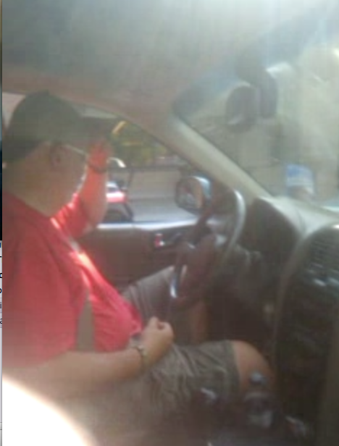

EXHIBIT C
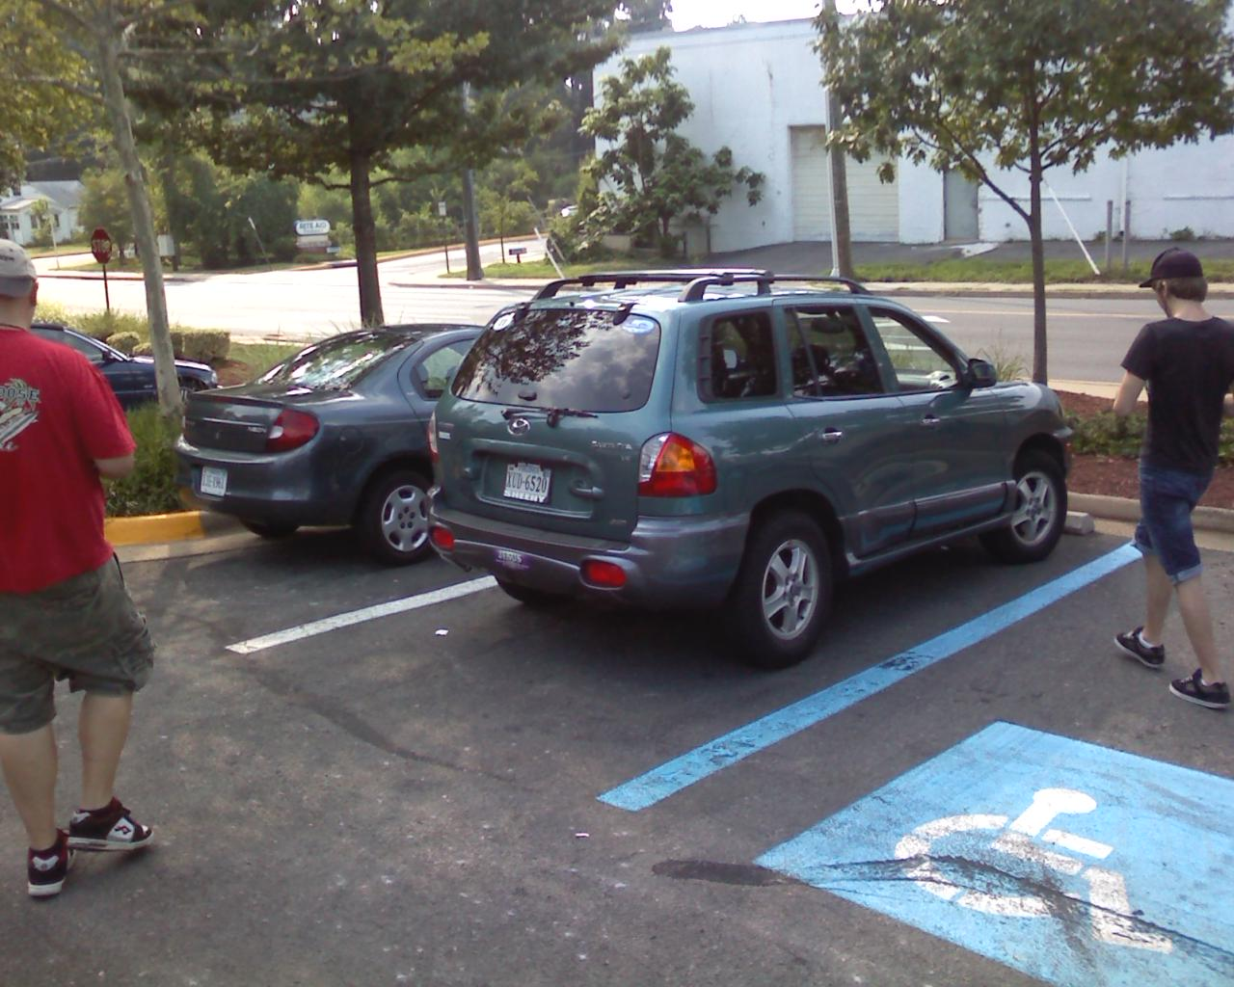

EXHIBIT D

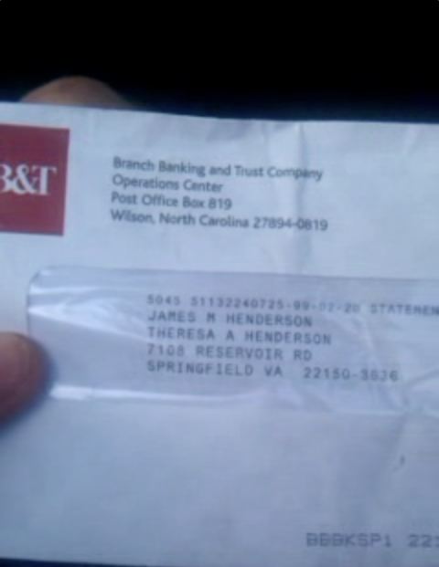

EXHIBIT E

Jul 22, 2010 04:00:16 PM, carnia54@yahoo.com wrote:
===========================================
Kyle Johnson July 14 at 1:12pm just don't understand why u hate me ... but that's what jules says.
Imiss seeing you, today the tears are bc I feel like I did something bystupid mistake and there's no second chance or fixing it.
Sent via Facebook Mobile
Zach Payne July 21 at 2:29pm hey jim im really sorry for acting so lame and gettin upset n junk.
ihate how you said i couldnt drink the beer juliuls got i was like ididnt think i hurt his feelings thatt much. but i overreacted too .just wanted to say that i guess.
Kyle Johnson July 21 at 2:33pm thanks for sending me this note ... can w just have a "do over"? Sent via Facebook Mobile
Zach Payne July 21 at 2:38pm derrrrrr. when julius said you said that i was like oh god. haha immglad were chill again. what have you been up too??????????
Kyle Johnson July 21 at 3:16pm two day trip to nc right now for a court thing ... actually headingback now ... jules prolly told u otherwise just being an ass Sent via Facebook Mobile
Zach Payne July 21 at 3:45pm yeah is whateva i drank it! haha. but why do you have court in north carolina?? shit girl whatd you do haha

EXHIBIT F

Yesterday 8:50pmKyle
hey zach
8:50pmMe
yahlow
whasssss up
8:51pmKyle
ijust wanted to say it's none of my business with whom jules shares whatthe fuck ever alcohol he gets ... whether from me or someone else
and it was stupid for me to tell him that
but it wasn't because i was hurt or angry
8:52pmMe
i dont even careeeeeeee haha you know if its alchohal it doesnt matter whos it is im gonna drank it
lol
8:52pmKyle
it was bc i thought it was a way to help you
and you didn't ask for my help
so it was just stupid interference
8:53pmMe
that was actually a really good night
haha
8:53pmKyle
good
was that the two twelve packs
8:53pmMe
yeah and vodka
8:53pmKyle
ahhhh
8:53pmMe
and i already had 4 4 locoooooo
haha
8:53pmKyle
well, i had none of it :-)
but i made a soda can pipe last night
and smoke about a half gram of pot
8:54pmMe
i would killll for some pot right now
8:54pmKyle
lol
8:54pmMe
whyd you goto nc
like is you in trouble
8:54pmKyle
no
you know i'm a lawyer
8:55pmMe
i thought you taught lawyers
8:55pmKyle
have a case down there
8:55pmMe
ah
8:55pmKyle
and just had to have a scheduling hearing with the judge
oh i teach too
but i also practice
8:55pmMe
tht would be afun job
8:56pmKyle
it can be
i actually have come to like the teaching more
8:56pmMe
i would like to be more hands on
8:56pmKyle
i've had lots of court experience
8:56pmMe
in defend niggas from payin they child support
8:56pmKyle
but when you teach
lol
you're in charge
8:57pmMe
yeah
8:57pmKyle
so where you at tonite?
8:57pmMe
tonight im at mattchews
8:59pmKyle
ido have some pot yet, its just getting out tonite that's the thing, youtwo gonna be around tomorrow, cuz i could bring some of it by for you,it's not a huge supply but it's some
8:59pmMe
tommorow i think were gonna be in dc at his gmaws all day but friday i know would be good
9:00pmKyle
in dc?
9:00pmMe
yeah his grandmaw lives in a nice part there
9:00pmKyle
like in northwest then
9:00pmMe
and shes chzeck or whateva and she wants to make us dinner and swim with her
yeah
it should be cute
9:01pmKyle
lol!!!
cool
9:01pmMe
or as ghetto girls say pa cute!
haha
9:01pmKyle
lol
well, keep the idea of friday in mind
9:01pmMe
i whill
we havent been doing shit latly and other than tommorow saturday late is the only other plan
9:02pmKyle
kk
9:05pmKyle
i'll let you be and i really mean thank you for reaching out to me, Zach!
9:06pmMe
nigga i overreacted and was going through my messages
and was like well shit
that was retarded
haha
9:07pmKyle
i'm just happy we cool
go have fun with u boyfrann
9:08pmMe
we cool my nigga we cool
im about to right now we got some mothafuckin wine n shit!
haha lata nigga
9:08pmKyle
kk

EXHIBIT G

